TestRail – Day 4: Test Cases – Fields, Templates & Test Design
Date: 27-Jan-2026
Learning Objective
• To understand test case components in TestRail
• To learn about test case fields and templates
• To define preconditions and expected results
• To design and write multiple structured test cases
1. Test Cases in TestRail
Definition:
• A test case is a documented set of steps used to validate a specific functionality and ensure the application behaves as expected.
Learning Points:
• Test cases define what to test and how to test
• Form the foundation of test execution and reporting
• Enable consistent and repeatable testing
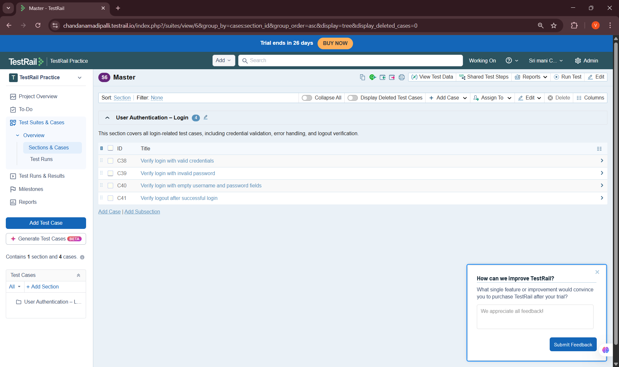
2. Test Case Fields
Definition:
• Test case fields are attributes used to describe and manage a test case in TestRail.
Common Fields Learned:
• Title
• Section
• Template
• Type
• Priority
• Preconditions
• Steps
• Expected Results
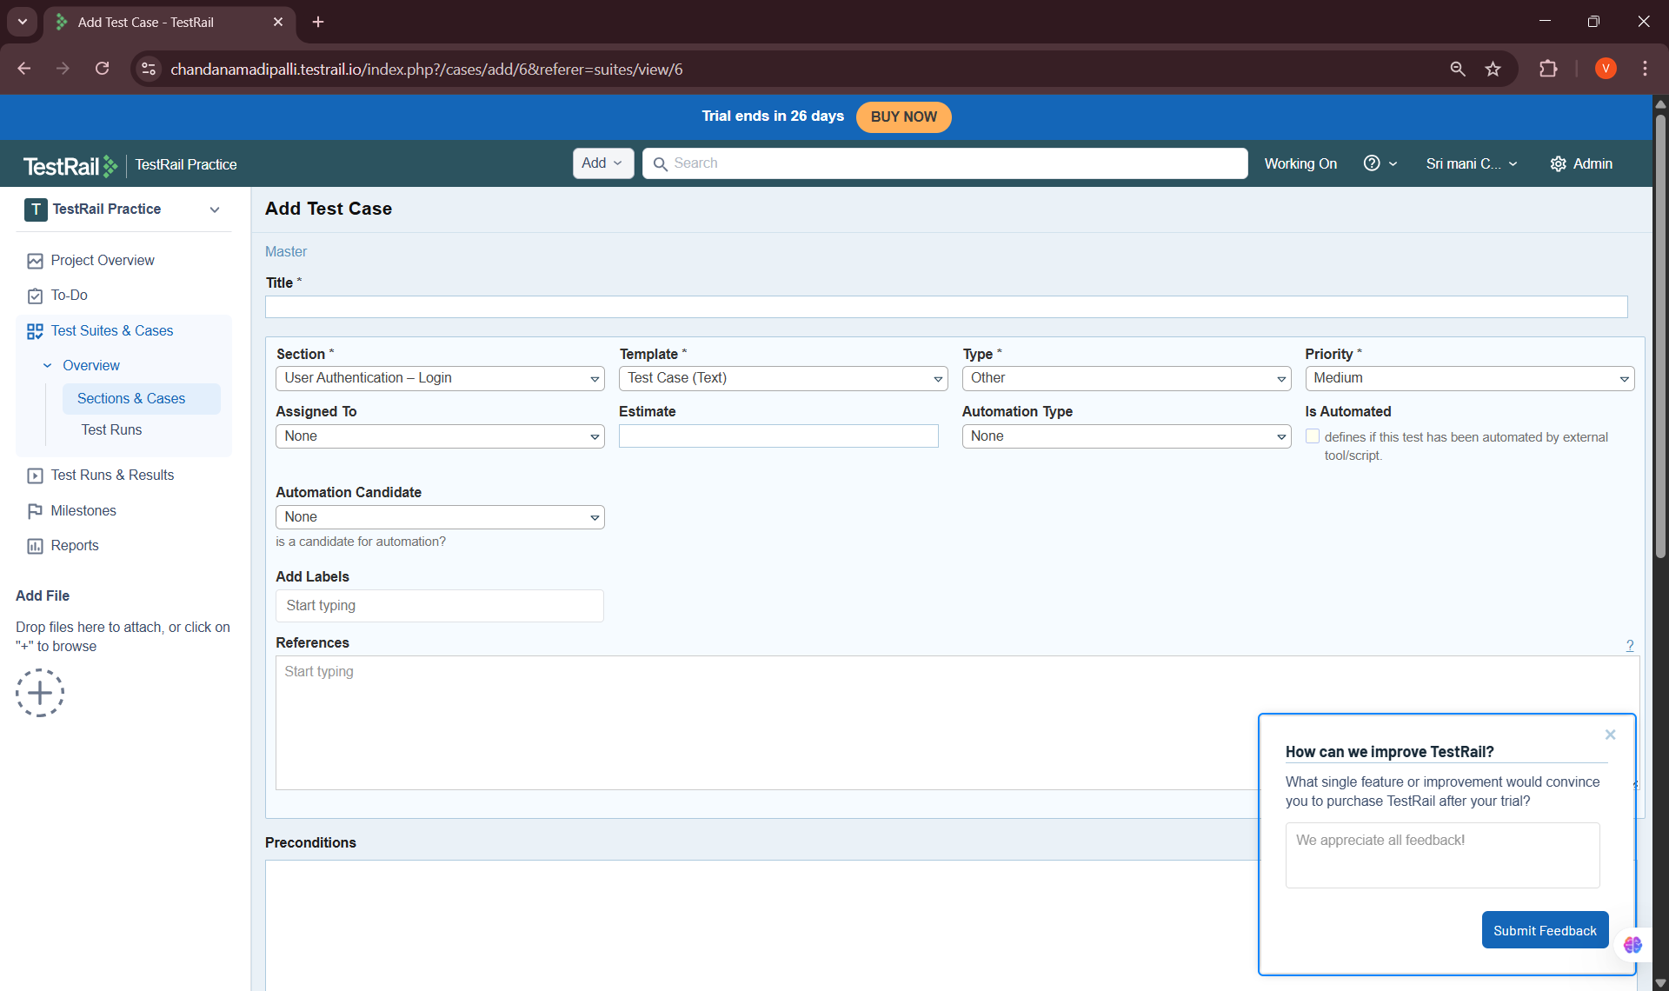
3. Test Case Templates
Definition:
• A test case template defines the structure of a test case, including the fields and layout used to capture test information.
Learning Points:
• Used predefined templates such as Test Case (Steps)
• Ensured consistency across all test cases
• Improved readability and standardization
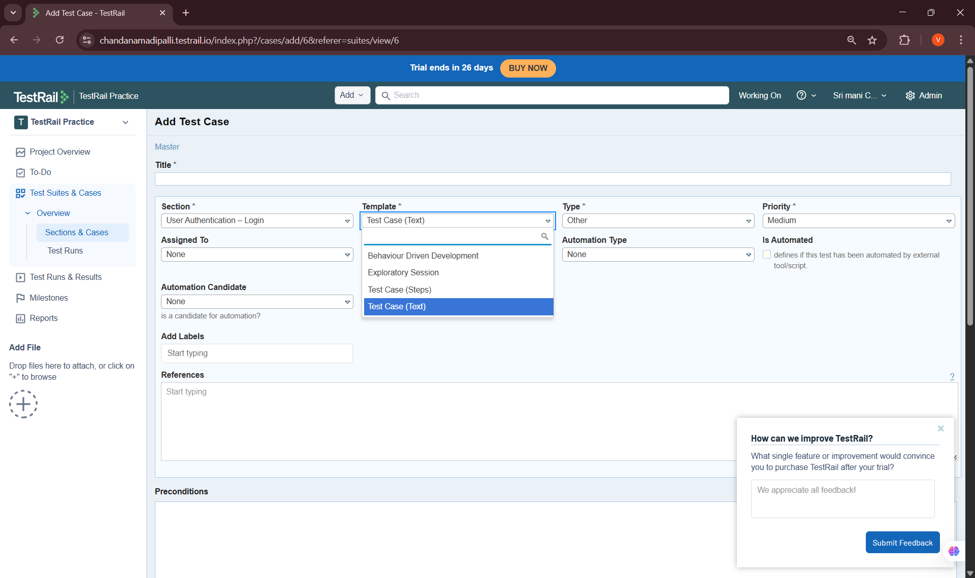
4. Preconditions
Definition:
• Preconditions describe the required system state before executing a test case.
Learning Points:
• Defined clear and reusable preconditions
• Avoided repeating setup steps in every test
• Improved test clarity
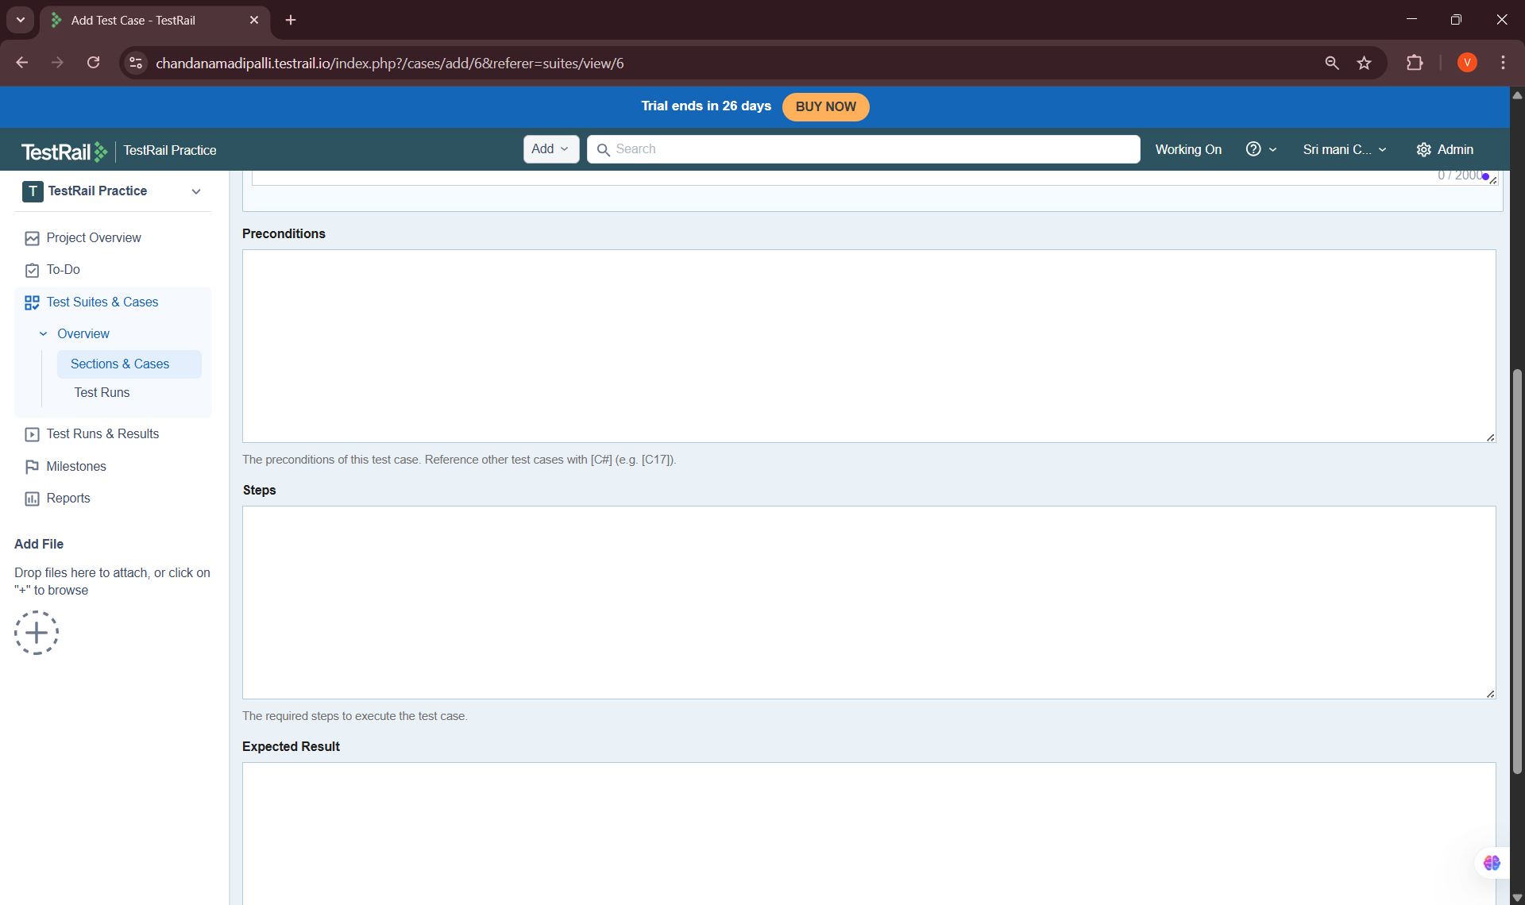
5. Expected Results
Definition:
• Expected results define the anticipated system behavior after executing each test step.
Learning Points:
• Clearly defined expected outcomes for each step
• Used measurable and observable results
• Ensured pass/fail criteria were unambiguos
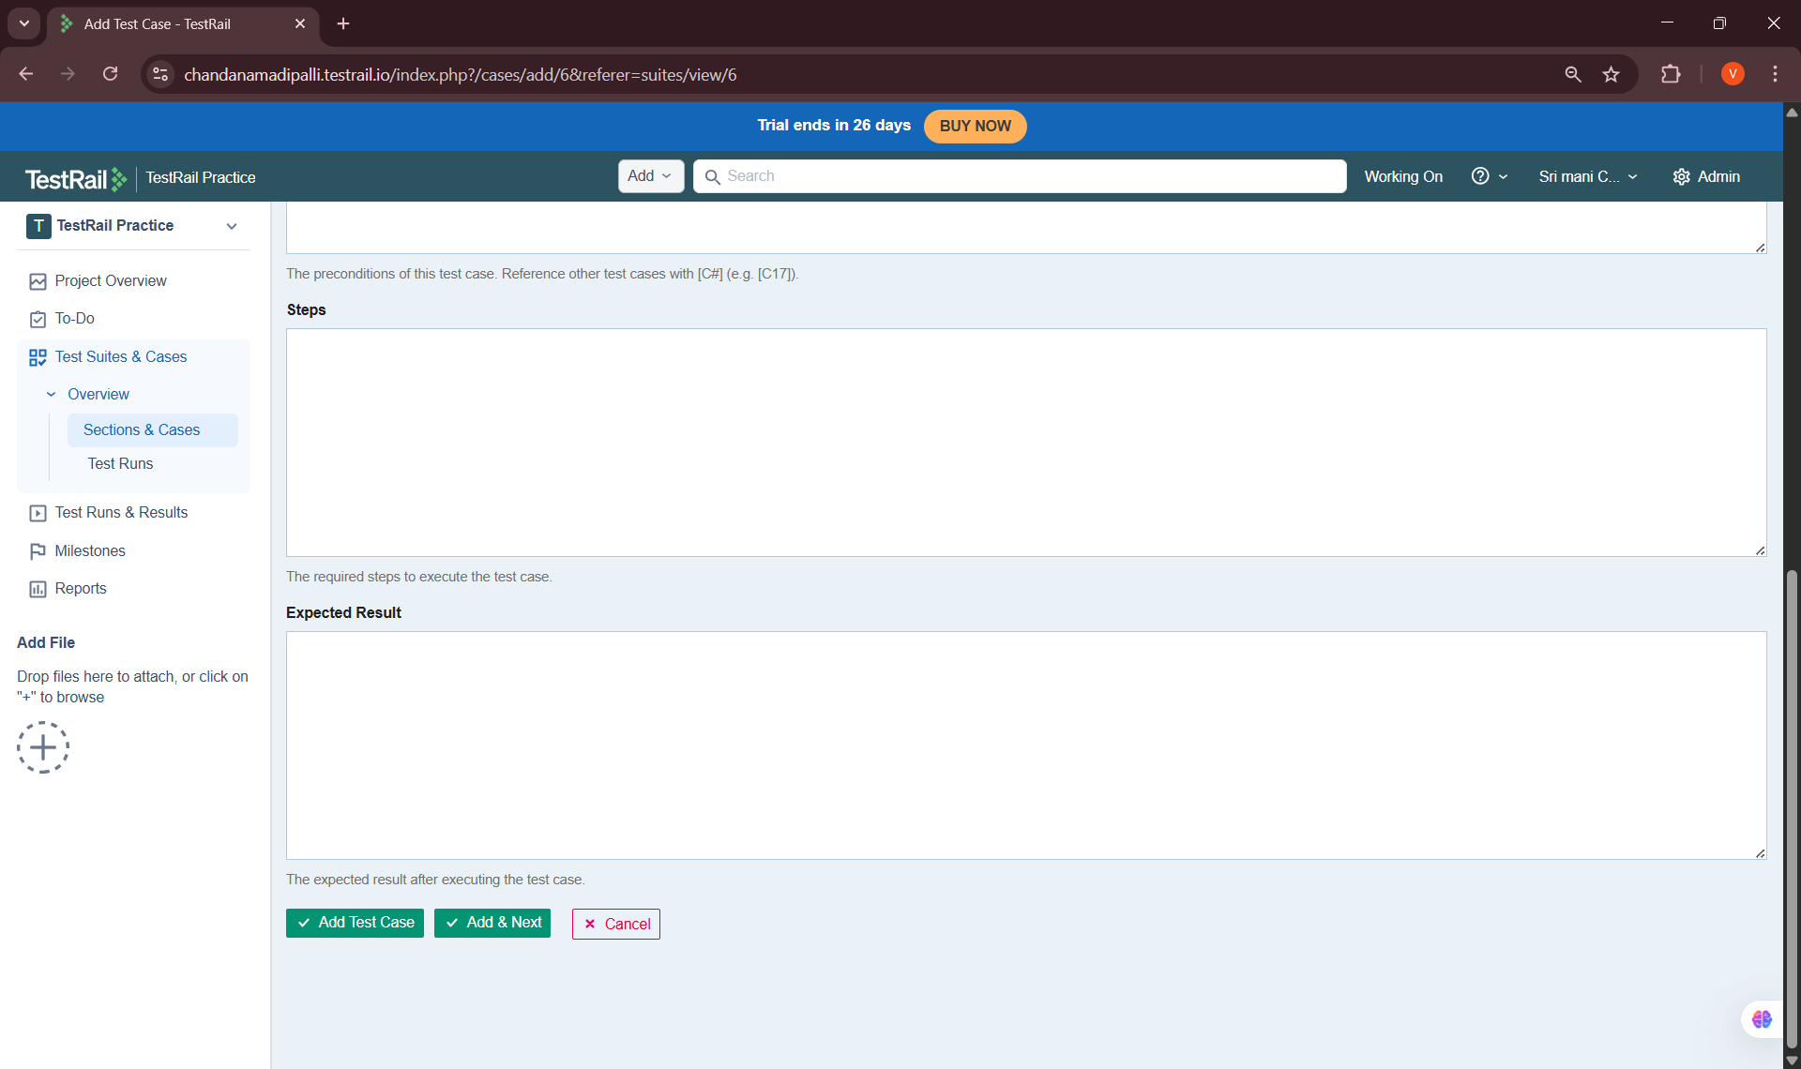
6. Writing Test Cases (Hands-On Practice)
Task Performed:
• Designed and documented 10 test cases
• Covered positive, negative, and validation scenarios
• Ensured consistent format and naming standards
Examples of Test Scenarios Covered:
• Valid login
• Invalid login
• Empty field validation
• Logout functionality
• Session timeout
• Password masking
• Error message validation
• Browser refresh behavior
• Remember-me option
• Multiple login attempts
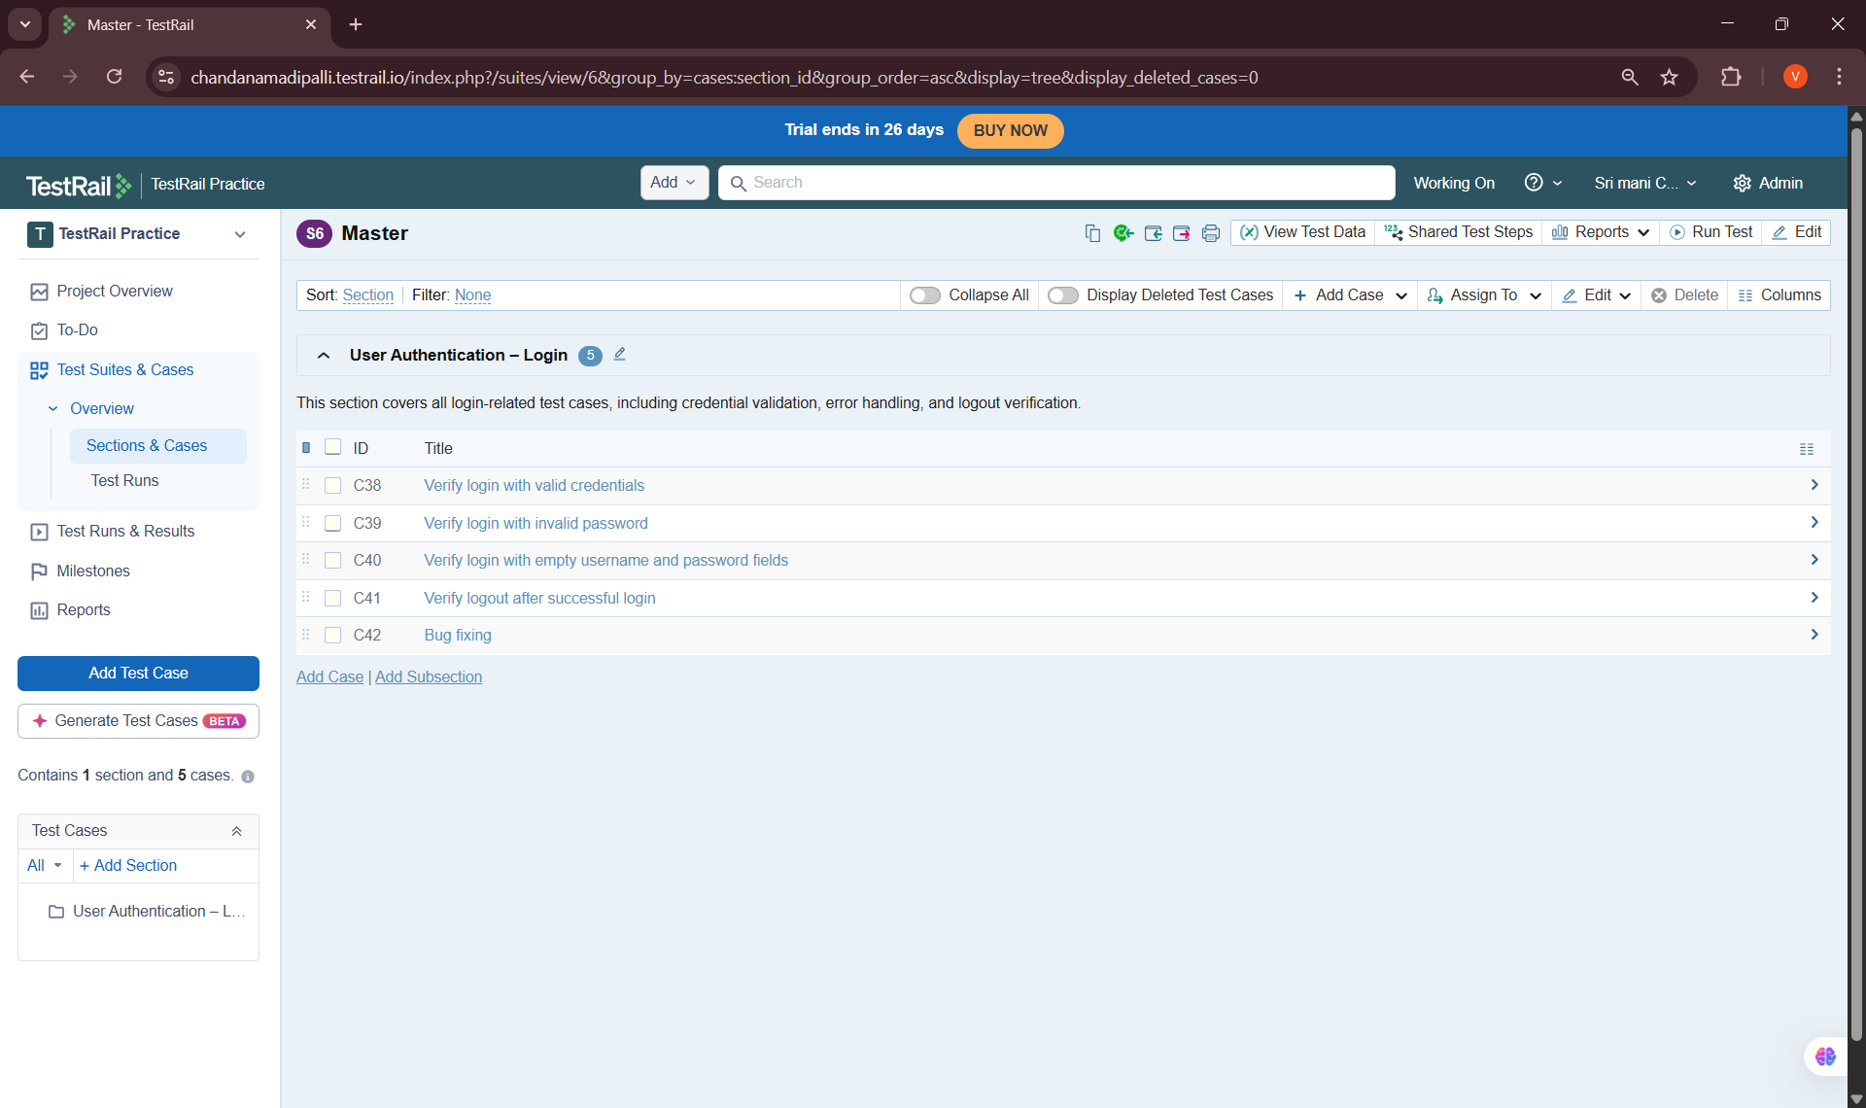

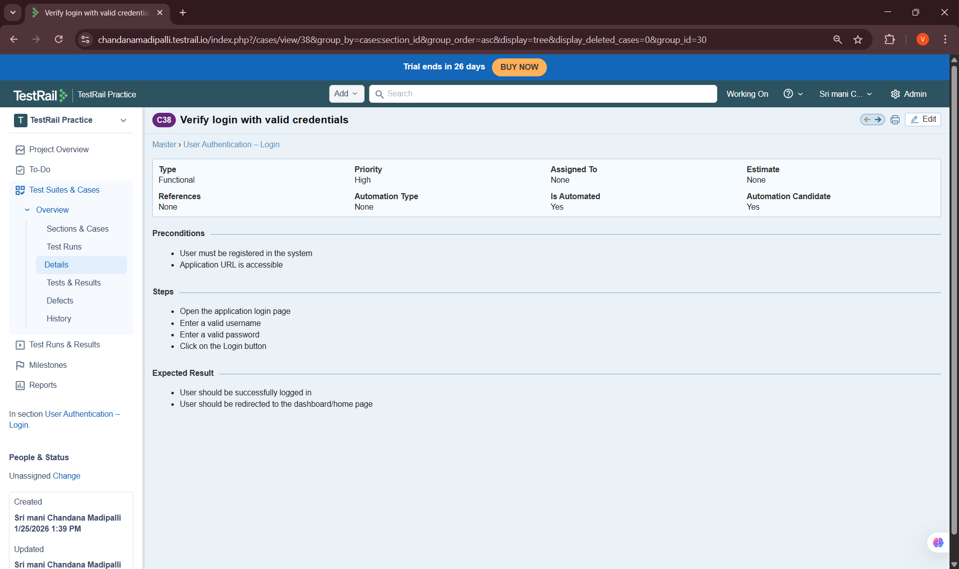
Key Learnings & Outcomes
• Understood test case structure and fields in TestRail
• Learned how to use templates for consistency
• Gained experience defining preconditions and expected results
• Successfully created and documented 10 structured test cases
• Built automation-ready and reusable test cases

